Minimum Spanning Tree (Check Class notes also)
A spanning tree is defined as a tree-like subgraph of a connected, undirected graph that includes all the vertices of the graph. it is a subset of the edges of the graph that forms a tree (acyclic) where every node of the graph is a part of the tree.
The minimum spanning tree has all the properties of a spanning tree with an added constraint of having the minimum possible weights among all possible spanning trees. Like a spanning tree, there can also be many possible MSTs for a graph.

Properties of a Spanning Tree
The spanning tree holds the below-mentioned principles:
- The number of vertices (V) in the graph and the spanning tree is the same.
- There is a fixed number of edges in the spanning tree which is equal to one less than the total number of vertices ( E = V-1 ).
- The spanning tree should not be disconnected, as in there should only be a single source of component, not more than that.
- The spanning tree should be acyclic, which means there would not be any cycle in the tree.
- The total cost (or weight) of the spanning tree is defined as the sum of the edge weights of all the edges of the spanning tree.
- There can be many possible spanning trees for a graph.
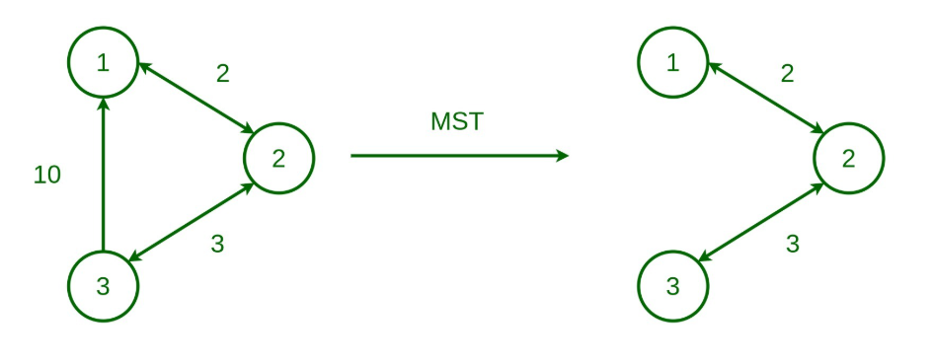
Fig: From Graph to MST.

